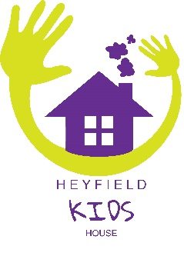
Heyfield Community Resource Centre
PO Box 201 (5 George Street), Heyfield VIC 3858
Ph 5148 2100
ABN: 19 707 886 634
Kid’s House Booking Form 2019
Family Name Date:
Child’s Name Preferred Start date
I would like my child’s attendance to be in (please tick)

6 months to 3 year-old
3 years + (need to be toilet trained)

Monday | Tuesday | Wednesday | Thursday | Friday

Note:
3 years + runs on Monday & Wednesday (age 3 before start of term and toilet trained)
6 month to 3 years + runs on Tuesday, Thursday & Friday.
*The days we will run in 2019 are dependent on numbers
Kid’s House is a nut free house. No Nutella, peanut butter or other product with nuts in it.
We require the child’s Immunisation History Statement from Medicare before they start. These can be obtained through your Medicare online account or the Express Plus Medicare mobile app, a local Medicare service centre or by requesting a statement be posted to them in the mail: – phone 1800 653 809 – email acir@medicareaustralia.gov.au
Fee per day is $50. CCS subsidy is available to eligible families. This will require registration through Centrelink. You will need to do this through my.gov.au. It is your responsibility to do this.
Parent’s name
Parent’s signature

